

Homework -3 – Jan-2021 Batch
8th March - 2021

Task 1: Environment Setup
Part 1: Jdk and eclipse is already installed in your computer. ( should already be done)
Install google chrome browser in your computer
https://www.google.com/chrome/
if you already have chrome browser, please make sure you have the most updated one.
Part 2: Selenium Setup
You can get the 2 selenium libraries in the following link, please download the jars from the github repository we are using for the class
Selenium java & Selenium standalone server
https://github.com/battlestar99/Feb2021/tree/master/libraries
copy the 2 jar files in a folder in your project, add them two build path to use the library jars.
Part 3:
To run your code on google chrome browser you need to download the google chrome driver file and set the system property in your code.
The link for the chrome driver library
http://chromedriver.chromium.org/downloads
You need to setup the chromdriver .exe file location in your code to open chrome browser, check the sample code here
http://www.automationtestinghub.com/selenium-chromedriver/
System.setProperty("webdriver.chrome.driver","D:\\Drivers\\chromedriver.exe");
WebDriver driver = new ChromeDriver();
Please check the sample code to make sure you are not making any mistakes.

Important things to remember: The chromedrive comes with multiple version, make sure your google chrome browser version and chromedriver version is same. So if your chrome browser version is 75, chromedriver version should be 75, if chromebrowser is 84, chromedriver should be 84 and so on.

Part 4:
Remember, you need to find the web elements attributes from the google chrome browser. If you find web elements in one browser you can run the test script in any browser as the attributes and values are same for any browser.

Task: 2: Answer the following questions
a. What is the role of java and selenium in writing automated functional testing script?
b. What is a Test script, how it is different from Test Case?
c. Explain if a Test script is a runnable or non-runnable class and why?
d. What are attributes and values for any web elements?
e. Explain how to find a web element to use in automation testing code?

Task 3: Write program for doing web browser interaction for the following scenarios given. Use webelements to store the webelement first and then do interaction with the application.
- Create a programming scripts using selenium library that will fill up the registration form from the following page, read the text in the sign up button, also read the URL and title of the page and print that in the console
https://www.phptravels.net/register
- Please fill up the yahoo login form

https://login.yahoo.com/account/create

- Navigate to the following link
http://automationpractice.com/index.php?controller=authentication&back=my-account
Go to the footer, see the links under information
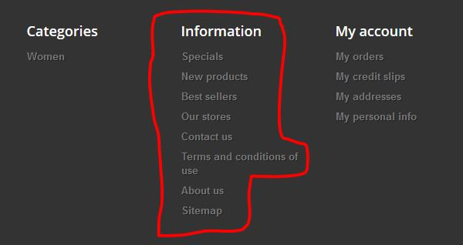
Click all the links one by one, starts with specials and ends in sitemap, after clicking each link when it navigates to the new page, read the title and url of the new page, print it in the console. Then come back again to the home page and click another link. Create a script to click all the links under Information.
Best Of luck

